**Practical 1: Study of Data Definition Language Statement**

**A) Write the query for the following**

**1) Create the following tables and include the necessary constraints NOT NULL, DEFAULT, CHECK, PRIMARY KEY, UNIQUE.**

a) Student (sid, sname, gender, dob, remark, marks, class, email)

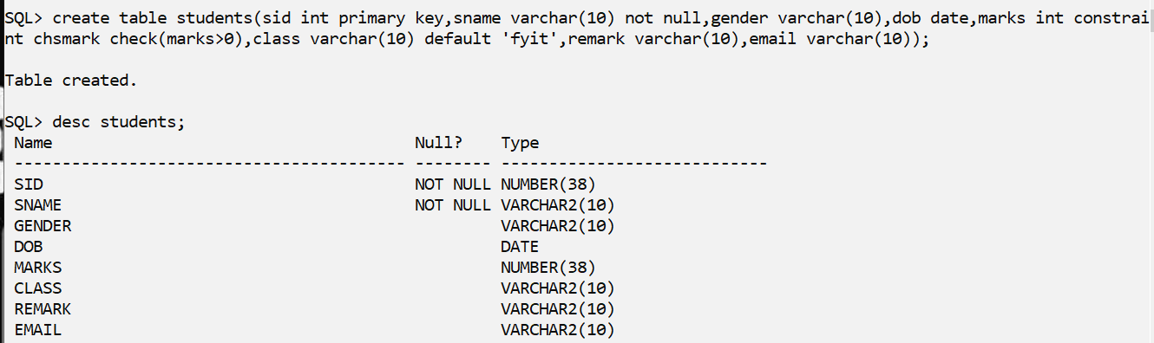

b) Course (cid, cname, credits)

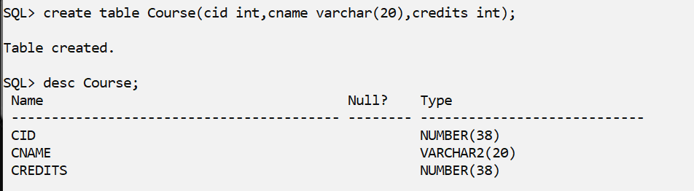

**2) Alter the structure of the Course table**

a) Modify datatype of cname.

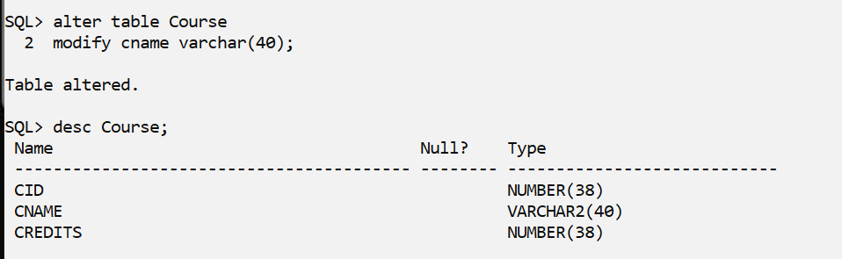

b) Add a column coursehours with minimum course hours greater than 45.

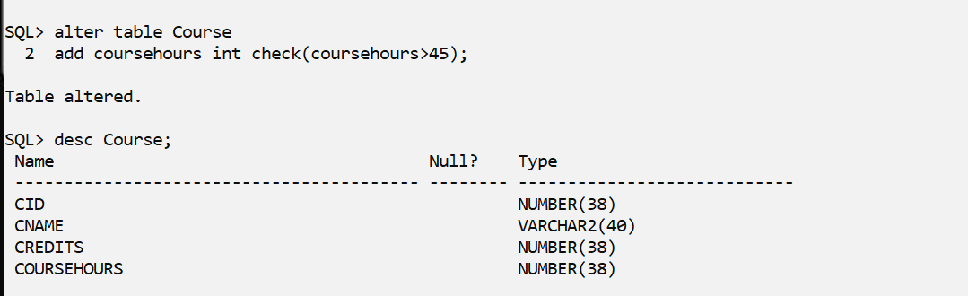

c) Add a column cdesc

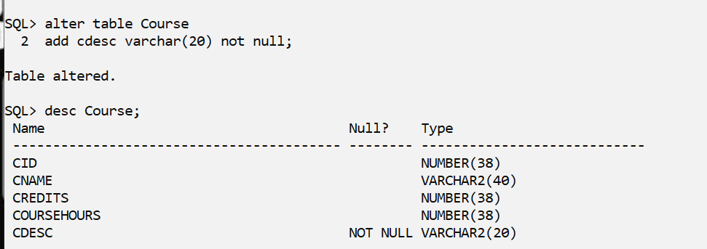

**3) Alter the structure of Student Table**

a) Add column age with minimum age as 17.

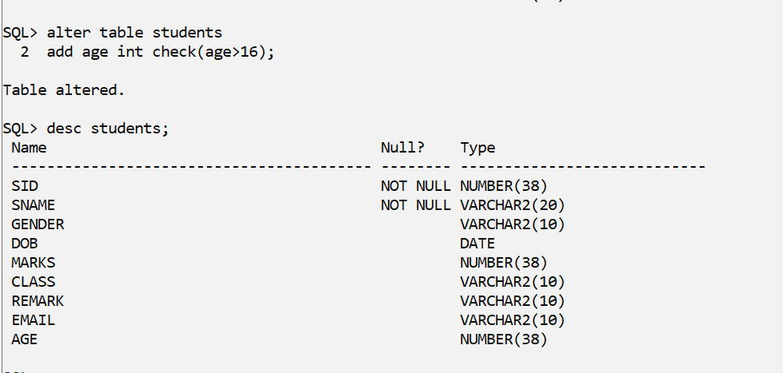

b) Delete the column dob

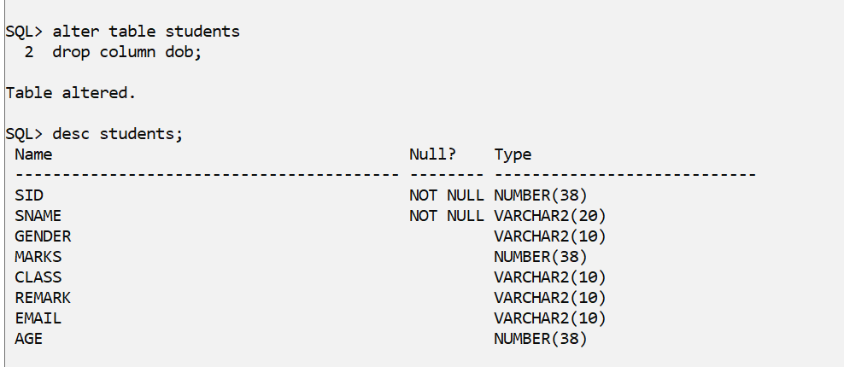

c) Add a column phoneno.

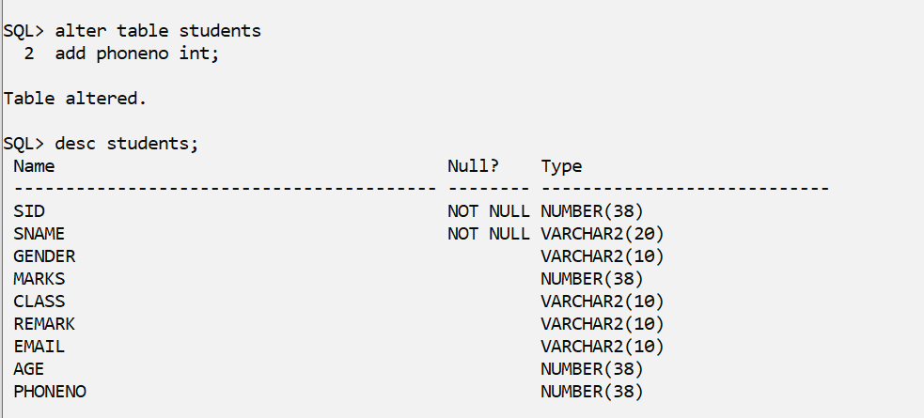

d) Rename phoneno to contactno

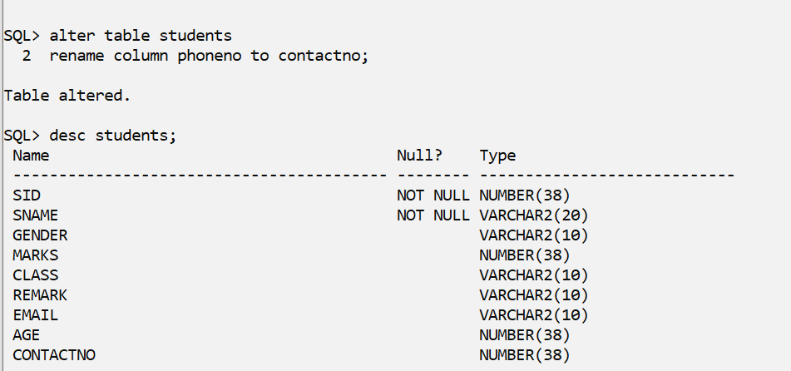

**4) Rename Student table as Student_details**.

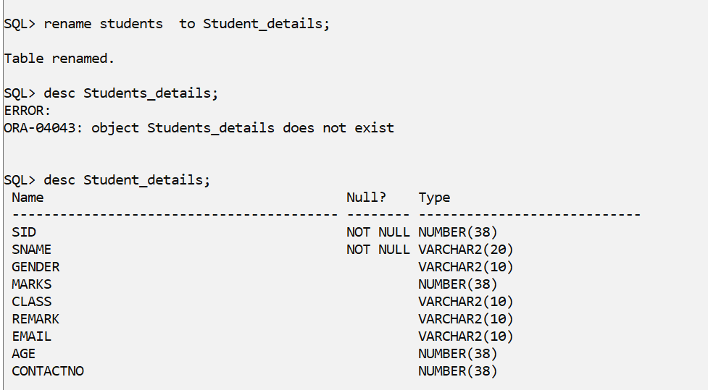

**5) Describe the structure of both the tables.**

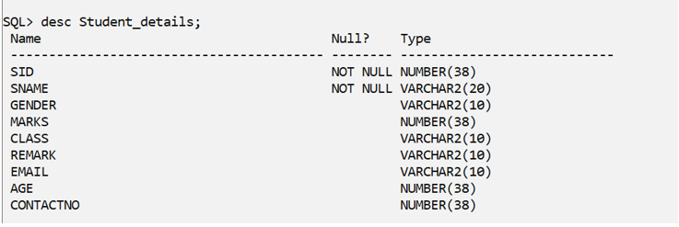

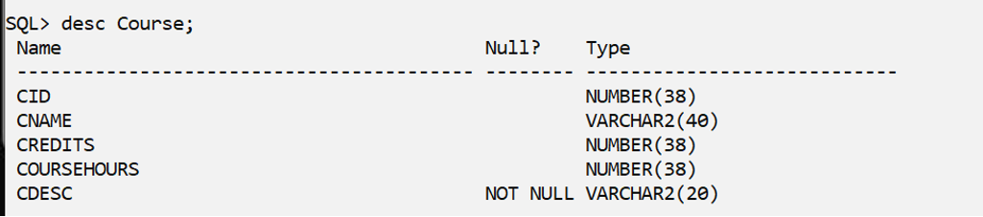

**6) Drop the table student_details and Course.**

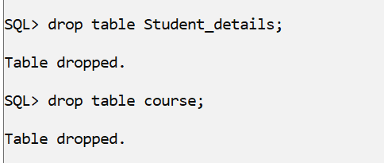

**B)** 1. Create a table EMPLOYEE with following attributes and specific data types and constraints required (Emp_no, E_name, E_address, E_ph_no, Dept_no, Dept_name, Job_id, Salary)

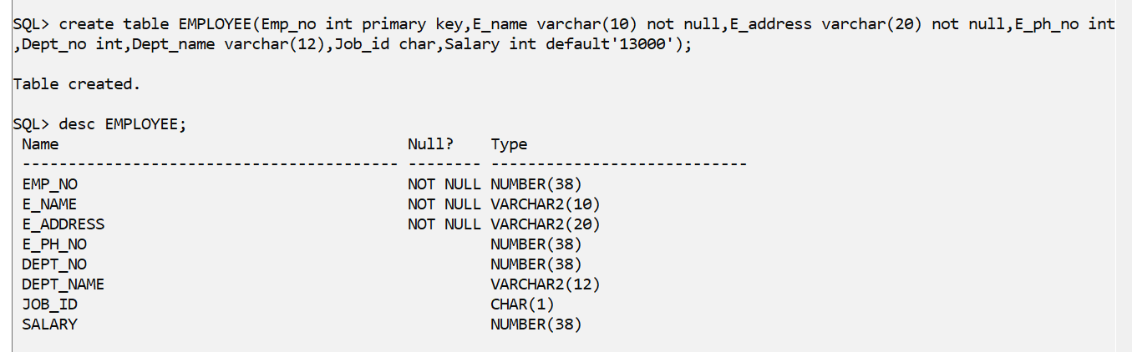

2. Add a new column HIREDATE to the existing relation.

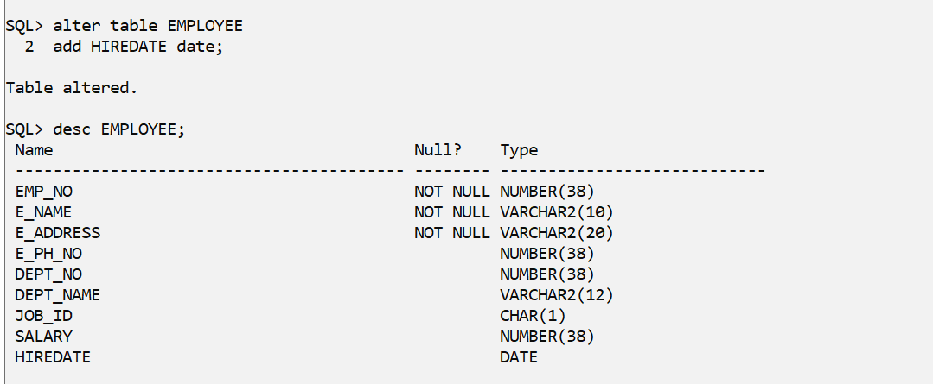

3. Change the datatype of JOB_ID from char to varchar2.

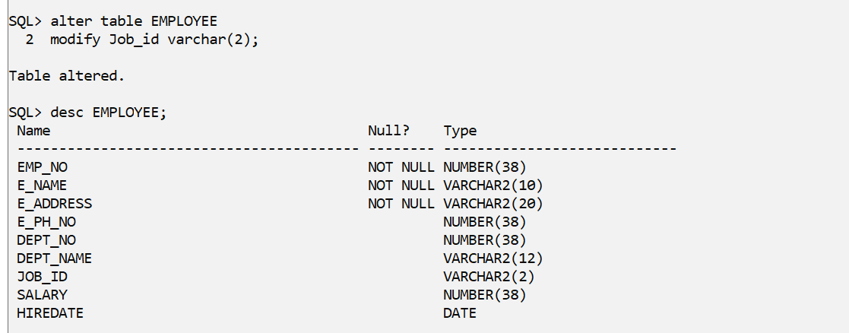

4. Change the name of column/field Emp_no to E_no.

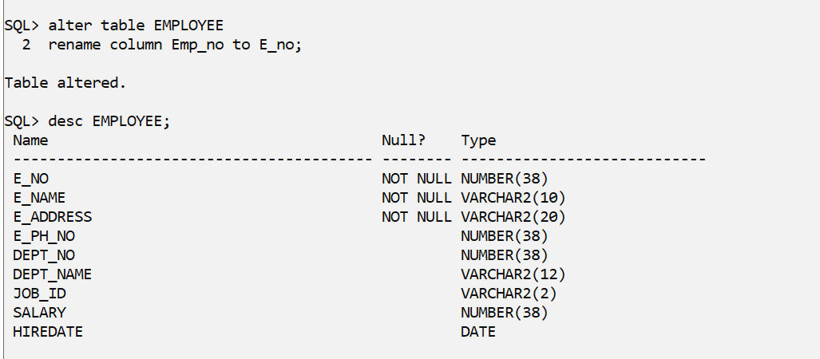

5. Modify the column width of the job field of emp table.

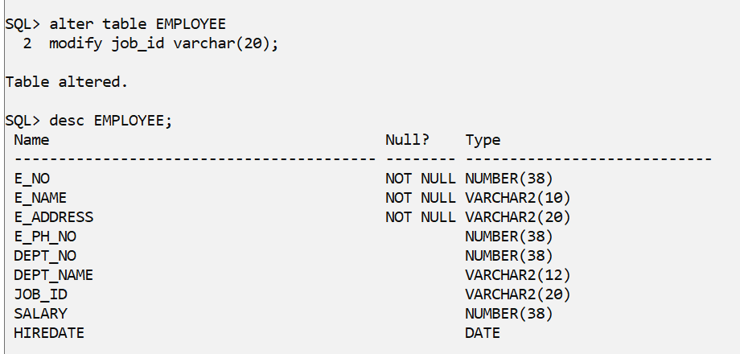

**C) Create the following tables with specified attributes and constraints Department Table:** Department_Id varchar2(20) primarykey, Department_Name varchar2(25) with required data**.**

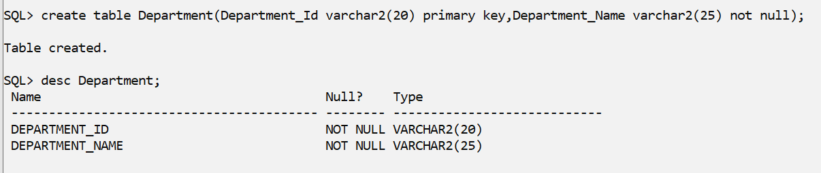

Instructor Table: Instructor_id varchar2(20) primary key, Department_Id varchar2(20) Foreign key, Last_Name varchar2(25), First_Name varchar2(200) must have value, Telephone varchar2(20) must be unique, gender char(1) must be either ‘F’or ‘M’,city varchar(10) default value must be ‘MUMBAI’.

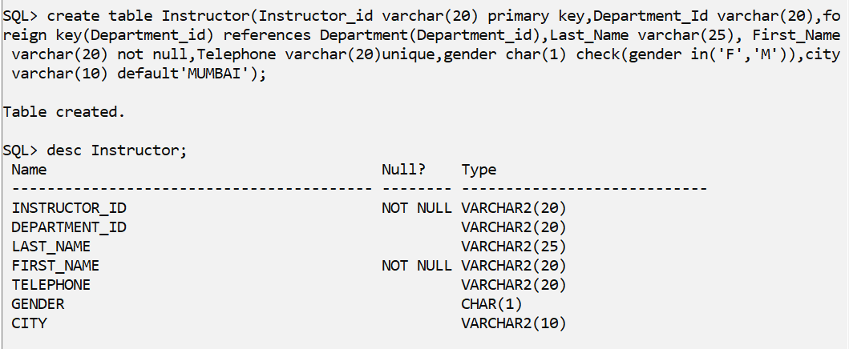

**D)Create the following described below:**

Table Name: EMP

|  |  |  |  |  |  |  |
| --- | --- | --- | --- | --- | --- | --- |
| Column | Data Type | Length | Precision | Scale | Primary Key | Nullable |
| EMPNO | Int | - | - | - | **Yes** | **-** |
| ENAME | Varchar2 | 10 | - | - | **-** | **No** |
| JOB | Varchar2 | 9 | - | - | **-** |  |
| MGR | Int | - | - | - | **-** |  |
| HIREDATE | Date | - | - | - | **-** |  |
| SAL | Number | - | 7 | 2 | **-** |  |
| COMM | Int | - | - | - | **-** |  |
| DEPTNO | Int | - | - | - | **-** |  |

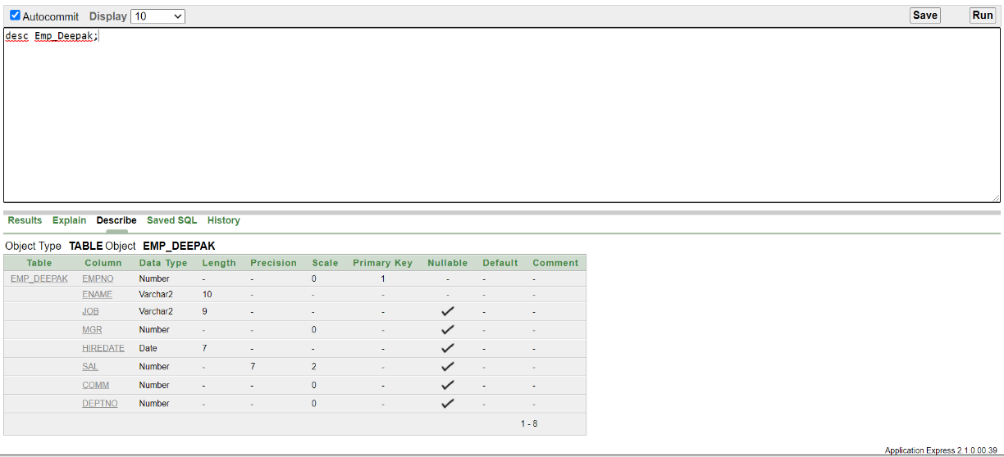

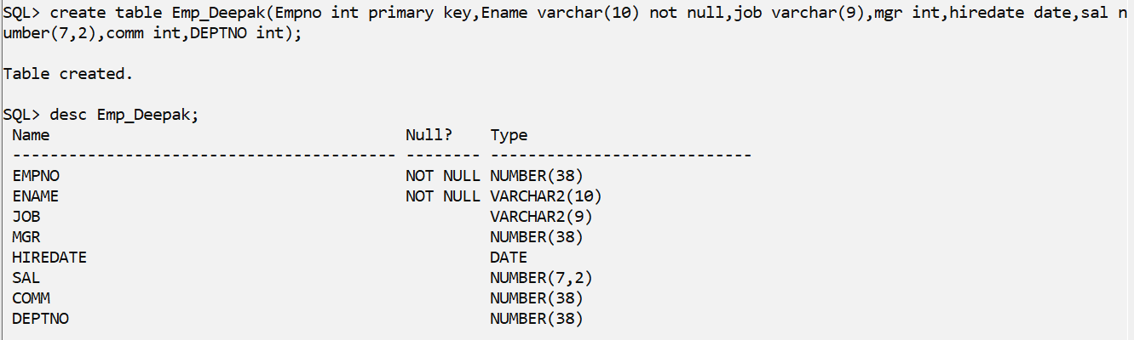

Table Name: DEPT

|  |  |  |  |  |  |  |
| --- | --- | --- | --- | --- | --- | --- |
| Column | Data Type | Length | Precision | Scale | Primary Key | Nullable |
| DEPTNO | Int | - | - | - | **Yes** | **-** |
| DNAME | Varchar2 | 14 | - | - | **-** | **No** |
| LOC | Varchar2 | 13 | - | - | **-** |  |

